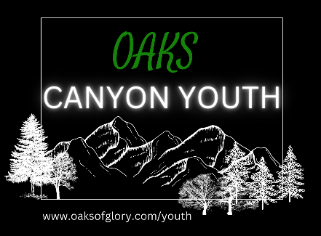 | 2023-2024 Product Order Form  Youth Pastors: Jeff & Halley Faville  503-580-2354; 503-509-8671  www.oaksofglory.com/youth  oakscanyonyouth@gmail.com
Name: Check #
Phone #: Email:
ITEM | QUANTITY | COST | TOTAL
Basic Scripture Portion: GEPCP * |  | $1.99
A Quizzer’s Daily Devotional* |  | $9.99
Scripture Portion w/ Concordance* |  | $11.99
Novice Quizzer’s Kit* |  | $22.99
Basic Scripture Portion: GEPCP—color** |  | $3.95
Listening CD** |  | $9.95
Quizzer’s 4 in 1 Scripture Portion** |  | $11.95
Quizzer’s Package** |  | $24.95

Links for direct orders:
*www.thefoundrypublishing.com/youthtop/quizzing.html
Novice Quizzer’s Kit includes The Beginner’s Guide for the New and Novice Quizzer, A Quizzer’s Daily Devotional, Practice Questions Book, Basic Scripture Portion
** ACME Quiz Products
Quizzer’s Package includes
- Study Guide. Daily devotions over the material, three daily study plans, and a growth journal make this product a must for each quizzer.
- Dramatized Listening CDs. Great for auditory learning.
- Questions: Choose either a QuizMaster Software license or printed questions
- Scripture: Choose either a B&W, Color-Highlighted, or combination 4-in-1 NIV with Scripture/Concordance/Lists. Tailor your package to suit your unique needs.

